Tasks:

Extract invoice number, invoice date, line items from invoice images. Also, the model structure should be scalable where we can train a model for any field and extract the key-value pair. Find sample data from the kaggle, huggingface, github. you can convert pdf files to image files.

Example is also attached for your reference.

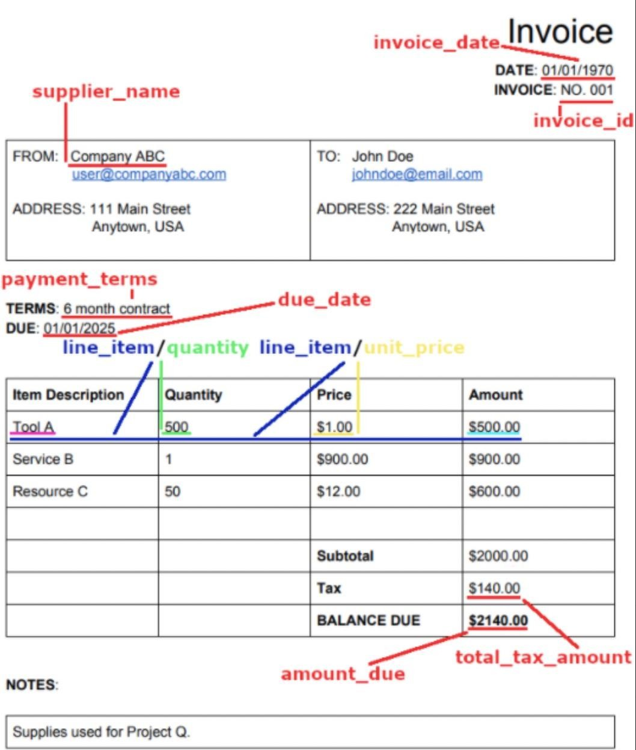

Time Duration: 48 Hours.

If you have any queries, please feel free to contact us.